bgskincare.com

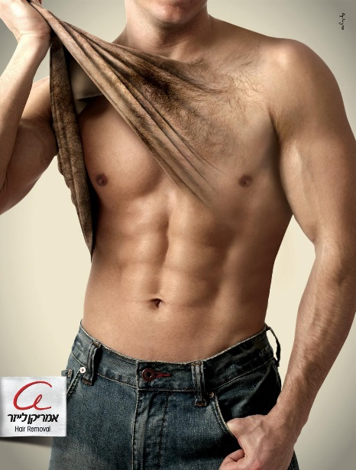

***Book your very own appointment today by going to bgskincare.com***

**We provide the following services by trained professionals:**

* **Exilis (fat cell dissipation & skin tightening) treatments**
* **Electrolysis & Laser Hair Removal**
* **Permanent Make-up**
* **Micro-current & LED light therapy**
* **Micro-dermabrasion**

**Once on our web page, click the calendar to the right, and select the day and time you would like to come into our clinic. Your appointment will be confirmed within 72 hours of online scheduling. All consultations are free so please log on and become part of the family! We are also available by phone 7 days a week: 8592761288 and will see you in the clinic!**